Python Assignment 1

Angad Singh Grover
21107028

Question 1
Write a Python program to find average of three numbers entered by the user.

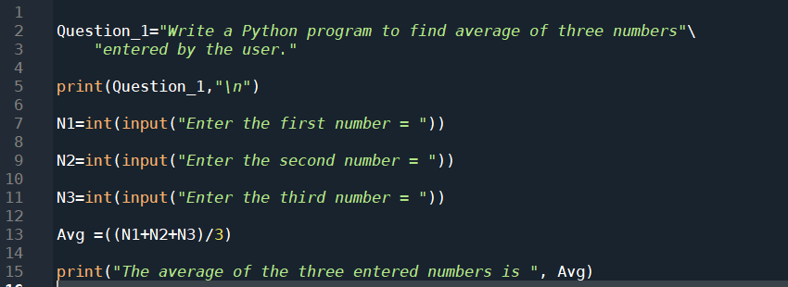
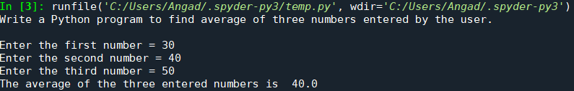
Question 2

Write a python program to compute a person's income tax. Assume following
tax laws:
• All taxpayers are charged a flat tax rate of 20%.
• All taxpayers are allowed a $10,000 standard deduction.
• For each dependent, a taxpayer is allowed an additional $3,000 deduction.
• Gross income must be entered to the nearest penny.
Gross Income and the number of dependents must be asked from the user.
Hint:
Taxable income = GrossIncome - Standard deduction - (Dependent deduction
* No. of dependents)
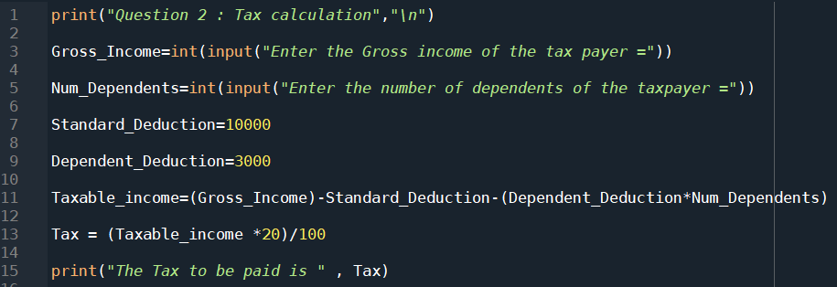
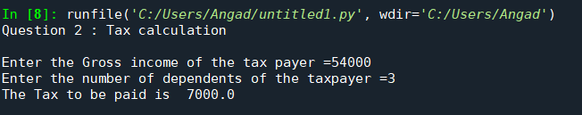
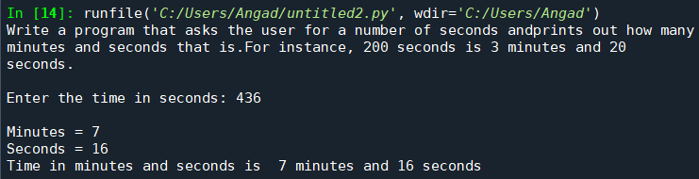

Question 3
Write a program that asks the user for a number of seconds and prints out
how many minutes and seconds that is. For instance, 200 seconds is 3
minutes and 20 seconds.

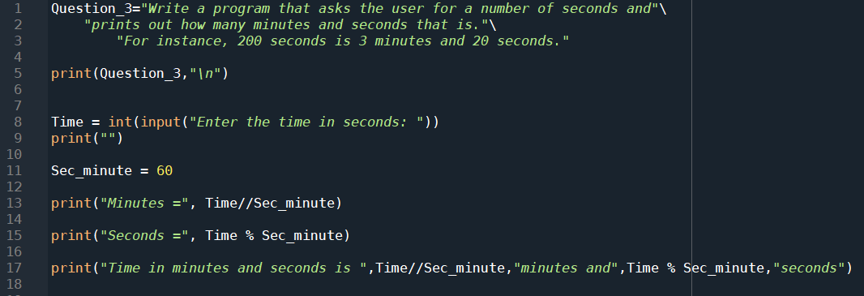

Question 4
Write a python program to add three numbers 25+’25’+25.0 and produce
result 75 as string.

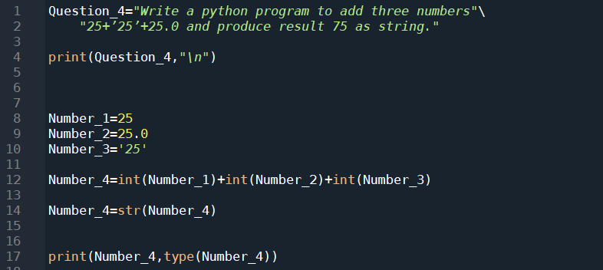

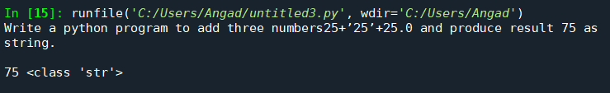

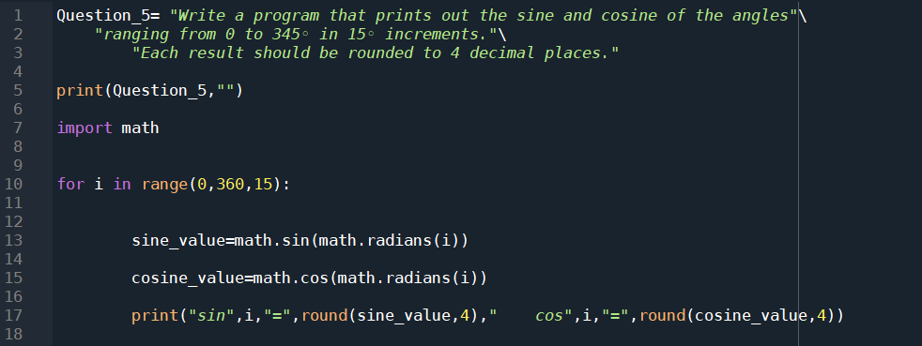
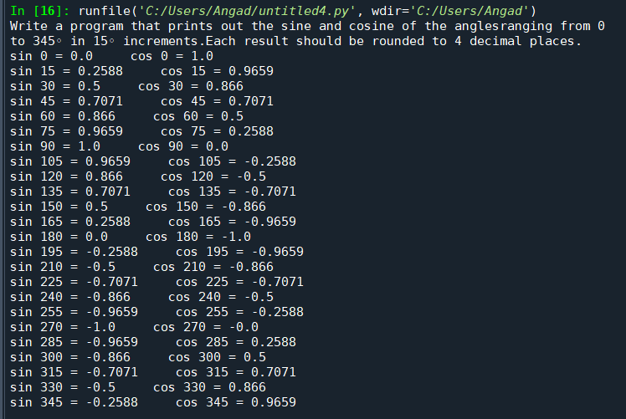
Question 5
Write a program that prints out the sine and cosine of the angles ranging from 0 to 345◦ in 15◦ increments. Each result should be rounded to 4 decimal places.

